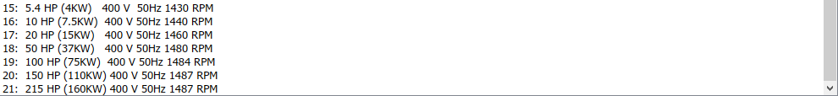

Gia to megisto dunato fortio:

Gia to elaxisto fortio:

Gia mia endiamesh katastash

